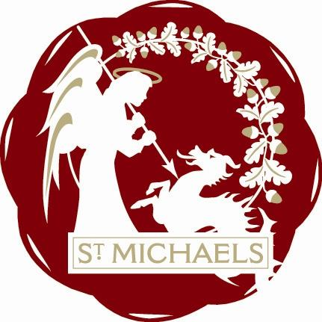
“Alis grave nil”

St.Michaels Village Community Group
www.stmichaelsvillage.com

Minutes of Meeting held on 16th September 2019 at London Beach at 7.30pm

Rob Solly in the Chair

Present: Trevor Bingham, Sandra Sutters, John Link, Rob Solly, Jo Vos,
Jean Curteis, Mike Dewdney, David Curteis

Apologies: Rosemary Dayborn, Colin Barns Lindsey Hammond, Jeanette Kennett, John Hoad,
Jamie & Liz Entwhistle, Gill Wittaker, Raymond Crawfurd

Minutes of Last Meeting
Acceptance of minutes proposed by John Link, seconded by Sandra Sutters and agreed by all.

Finance: See Robs report attached

Tributes: Report attached

Remembrance:
Will now include all people who lost their lives in both 1st and2nd world wars
Trevor will investigate names
Poppy display as last year will be installed on 2nd November and stay in situ until we erect Christmas tree
We will use poppy wreath from last year for Church and make a donation to British Legion

Christmas:
/Sandra will speak to Dave East about checking the tree and being on hand when we erect it.
Ask Harry to be Father Christmas
Complete Road Closure forms
Village hall booked for Childrens Party
Confirm booking for Disco
See Lindsey re Church Service
Rob to enquire about organ
Enquire about Rhythm of Life choir
Query floodlighting
Invite Mayor to switch on tree

Loneliness /Befriending
This item held over as Raymond not present

Fundraising:
As Sandra has licence Christmas raffle will be larger and tickets will be sold prior to event.

Sandra has been approached by Sinden Theatre about assisting with Tribute Acts for Theatre
They will sell the tickets and we will get a share of the takings for our funds

AOB
Jo Vos spoke about “Mens Shed”
This is an Australian idea and is being tried at The Glebe Hall.
This is for retired males and those who are lonely to come together and work on community
Projects.

Rosemary advised that she had called and welcomed the new barbers shop to the Village

Next Meeting : 21st October 2019 at London Beach at 7.30pm

Chairman: Rob Solly.

