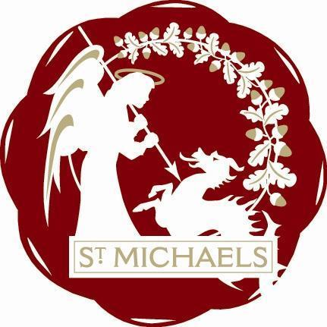
“Alis grave nil”

St.Michaels Village Community Group
www.stmichaelsvillage.com

Minutes of Meeting held on 22nd July 2019 at London Beach at 7.30pm

Trevor Bingham in the Chair

Present: Trevor Bingham, Sandra Sutters, John Link, , Rosemary Dayborn, Jo Vos,
John Hoad, Gill Wittaker, Daf Lindsay, Raymond Crawfurd, Alison Lewis, Janet Solly

Apologies: Lindsey Hammond, Jeanette Kennett, Jamie & Liz Entwhistle, Mike Dewdney,
Rob Solly, Jean Curteis, Colin Barnes

Minutes of Last Meeting: There were no minutes of last meeting as it was all about Tributes in the
Park

Finance:
Sounds good, but the Treasurer is on holiday! Balance in the bank is £4191.28 Still some bills to pay and some Grants to come in. Accounts for Tributes and General monies will be finalised by next meeting.

Tributes
Feedback from members of the public have been very positive. Tributes was again an unqualified success. Everyone involved should give themselves a pat on the back. All Raffle prizes have been collected/delivered. The audience were generous and we will be able to cover the cost of the event with moneys donated and the Council Grants.
Ideas for next year - Move the Raffle next to the Tea Tent, Have better signage for Tea Tent. Better signage for recycling, and try to get proper recycling bins.
Book last years Ice Cream Van.
Probably change the running of the bar, as no contribution from The Crown seems likely.
There were two unanimous votes: one for NO commercial stalls, and a YES, for inhouse facepaining for the children, to be free of charge/voluntary contribution
There needs to be a Timetable for all the jobs people do and a Rota of who is doing what and when.
Decisions had to be made regarding the date of the event, so we do not clash with other events happening locally. Date is going to be Saturday 13th June 2020, so don’t book your holidays then please. The Schools Choir is going to be asked to open the show - is there any way we can improve the sound so all can hear the choirs. The band Queen is to be booked ( now confirmed) Maddie , Natalie and Elvis Presley to be booked for the new date. Other acts being considered , depending on availability and price, are Elton John and Rollling Stones. Everyone at the meeting agreed that this format of well loved artists tribute acts works so well, we should not change it.

There is going to be a Fund Raising event at London Beach on 23rd April 2020 with Maddie as the entertainment. Please support this event as it is necessary to raise the funds for next years Tributes.

Loneliness /Befriending
It was agreed that the re-formation of the Good Companions is a good idea and a weekly meeting would be best. It needs an organisation to run it, and Raymond is to have talks with the WI to see if this could come under their umbrella. Once there is someone in charge it is probable there would be volunteers to help. It was suggested that a Sunday afternoon would be a good time and the Village Hall is the appropriate venue. John Link said that there is a KCC Tea Van/ Pop up Cafe. Raymond to persue this line of enquiry.

Christmas Switch- On Sunday 1st December
Details to be dealt with at the next meeting, but there is a need to book the Village Hall, please Jean,
The Barrel Organ for the point, please Rob, Jonathan the Magician, please Sandra and someone to ask Harry Hickmott if he can represent Father Christmas for us again.

AOB

Rosemary has requested that someone take over running the Facebook Page, and writing the minutes.

Date of next meeting: Monday 16th September 2019

Chair:

