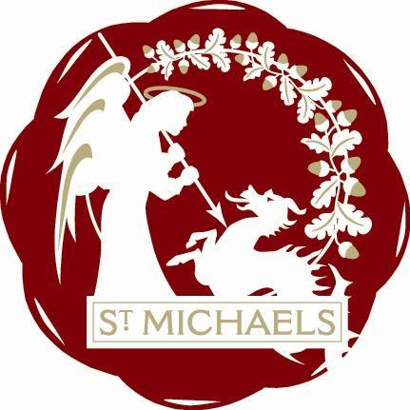
Minutes of AGM Meeting held on 28th January 2019
at London Beach at 7.00pm

Trevor Bingham in the Chair

Present: Rosemary Dayborn, Jean Curteis, Trevor Bingham, John Hoad, Rob Solly, John Link, Matthew Freeman, Sandra Sutters, Mike Dewdney, Lindsey Hammond and Jeanette Kennett, Colin Barnes. Gill Whitaker, Jo Vos.
Apologies: Jamie & Liz Entwhistle, Daphne Lindsey.

Welcome to Shawn Mead - new member of the group

Minutes of last AGM
The minutes of the last AGM were agreed by all

Chairmans Report
See attached report

Tresurers Report
See attached report

Election of Officers for 2019
Chairman and Deputy Chairman - Do we continue with current format or is there someone who wants the role for the year.
A vote was taken and all agreed to keep the status quo, but with one amendment regarding the post of Chairman, Trevor suggested that whoever is Chair for the month should also be co-ordinator for decisions during the coming month.

Treasurer:
Rob Solly was proposed by Trevor Bingham, seconded by Raymond Crawfurd. The vote was unanimous .
Rob Solly agreed to continue in this role with Jean Curteis as back up.

Secretary:
Jean Curteis was proposed by Trevor Bingham. seconded by Rob Solly. The vote was unanimous.
Jean Curteis has agreed to continues as secretary with Rosemary Dayborn as back up

St Michaels Community Group
Treasurers Annual report

I have distributed a ‘profit and loss’ account.

Points to note:

This is for the period 01 August 2017 – 31st July 2018.

You will notice that the income and expenditure appears considerably more than previous years. This is due to the fact that this years accounts take into consideration TWO Tributes in the Park – September 2017 and July 2018.

In conclusion, another good year in which we held our heads above water with a total income over expenditure of £47.38.

