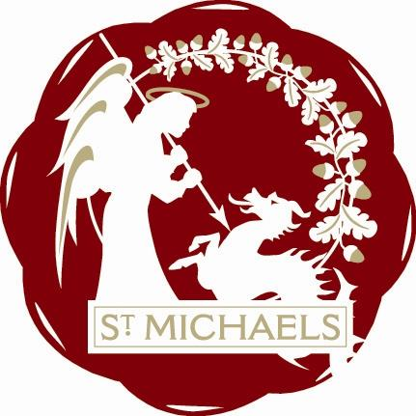
“Alis grave nil”

St.Michaels Village Community Group
www.stmichaelsvillage.com

Minutes of Meeting held on 16th April 2018 at London Beach at 7.30pm

Rosemary Dayborn in the Chair

Present: Rosemary Dayborn, Jean Curteis, Trevor Bingham, Sandra Sutters, Colin Barnes, John Hoad, Gill Whitaker

Apologies: Mike Dewdney, Jo Vos, Lindsey Hammond, Jamie & Liz Entwhistle , John Link,
Rob Solly, Raymond Crawfurd

Welcome: A warm welcome to Daphne Lindsey who joined us this evening

Minutes of Last Meeting:
Acceptance of March minutes agreed.

Matters Arising:
John Hoad reported that he had spoken to Mrs. Foreman and has the maintenance of the bench
at the post office in hand
After discussion it was felt that the scheme operating at Appledore is not quite what we are looking for.

Finance:
Bank Balance £3514.52. Details at next meeting

Tributes:
We now have all the tribute acts in place and are busy fund raising.
Jean and Rosemary have an appointment at ABC on Wednesday to hopefully secure funding for 3years.
TTC have agreed to make it a Town Event and subject to paperwork will be funded annually.
Gill has been in touch with the local netball team and they are willing to do bucket collections on the day.
She will also contact the school to see if the Children who were involved in the production of Oliver at the Sinden Theatre would like to do the opening spot at our event with some songs from the musical.

Our sincere thanks to Colin for organising the quiz at the Crown.
It was very well supported, lots of fun and everyone said how much they enjoyed it.
About £165.00 was made towards the tributes costs

St. Michaels Bites
Trevor discussed his progresss on the “Bites” so far, and it was agreed that we can, with a few more items and some adverts to cover costs. go to 8 pages this time.
Sandra to progress the adverts.
As we have a new Councillor in St. Michaels, Jean suggested we do a feature showing all FIVE
St. Michaels Councillors with their details They are all here to help anyone who has concerns about anything in the Village.

AOB

Gill reported on the information she has so far obtained from the Woodland Trust about tree planting.
She is awaiting more details from them and will report to the next meeting.

Next Meeting : 21st May 2018 at London Beach at 7.30pm

Chair for Next Meeting - Jean Curteis

