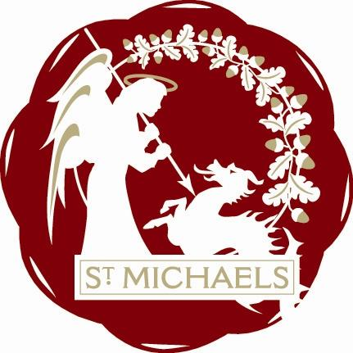

St.Michaels Village Community Group
www.stmichaelsvillage.com

Minutes of AGM Meeting held on Monday 15th January 2018 at London Beach at 7.00p.m.

Present: Rosemary Dayborn, Trevor Bingham, Jean Curteis, Rob Solly, Sandra Sutters, Colin Barnes, John Link, John Hoad,

Apologies: Lindsey Hammond, Mike Dewdney, Jo Vos, Jamie & Liz Entwhistle,

Welcome: Gill Whitaker, Ivan & Sue Rush

Minutes
The minutes of the last AGM were read, approved and signed.

Chairman’s Report
See attached resume

Treasurers Report
See attached report

Election of Officers for 2017
It was decided to continue with the same format as 2017 and have a monthly Chairman.

Treasurer: Rob Solly
Nominated by Jean Curteis and seconded by Sandra Sutters

Secretary: Jean Curteis
Nominated by John Link and seconded by Rob Solly

Election of Auditors
It has been decided that as we are not a Charity we will have our accounts audited inhouse.

AOB None

Resume of 2017

The St Michaels Community Group has worked hard during the last year and members should give themselves a pat on the back. Listed below is an overview of the years achievements.

St Mikes Bites - Two editions published during this year. A full version in August to advertise the Tributes in the Park and a single page edition giving details of Christmas festivities.

Tributes in the Park- Sept 2nd The event proved to be a fantastic success way beyond all expectations. The Acts were all well received, the sun shone and it was a perfect family day. A raffle was held in aid of the Tenterden Mayors charities. A Treasurers report for the day is attached and shows that although it was expensive to put on, a small profit was made. Thanks go to all who gave donations and Councils and Councillors who gave grants.

Ox Lane Green - Previous years have seen this untidy area mown and hedge cut. This year a permanent planter has been installed with permission from KCC Highways, and is now being maintained by local volunteers.

Flowers at the Point- Initally the planting this year looked good, but did not thrive. The planters now have a winter selection and are cheering up this area. These four small planters are being maintained by another volunteer.

Christmas - The Switch On event started with a service at the Church and the candle light procession down to the point. The Christmas Tree was erected and electricity checked previously and blessed at the event. The Remembrance Angels were put round the tree, The childrens party with disco and entertainment was a great success. The festivities continued into the evening at The Crown pub.

Facebook - Management of the Facebook Page has been extended and we have tried to extend the information available for residents.

ST MICHAELS VILLAGE COMMUNITY GROUP
Treasurers sub report –October 2017

I have now had time to collate a brief ‘profit and loss account’ in respect of the Tributes in the Park event.

Income

£
337 fund raising*
2500 ABC
1000 donation
2668.90 collection on the day
910 BBQ

  - Expenditure

Bands 3100
Insurance 221.32
Printing 294.12
Stage 2700.00
Toilets 180.00
St Johns 198.72
Traffic cones 294.12

6988.28

Total ‘profit’ £427.62

* I have not included the money raised from Sandra’s events and suggest we carry this forward to ‘underwrite’ any future events

ST MICHAELS VILLAGE COMMUNITY GROUP
RECEIPTS AND PAYMENTS ACCOUNT
FOR THE
YEAR END JULY 2017

Balance in Hand 01 August 2016 2,082.66

Sundry Income 3,441,37
Interest
5524.03

Payments

Tree 162
The Point 220.97
Insurance 124.15
Printing and Stationary 104
Donations
Sundries 498.01
Tributes 50.00
…….. 1159.13
……….

Balance in Hand 31 July 2017 4526.81

TREASURER

…………………………

We have prepared the above Receipts and Payments Accounts from the books and information supplied and certified it to be in accordance therewith.

