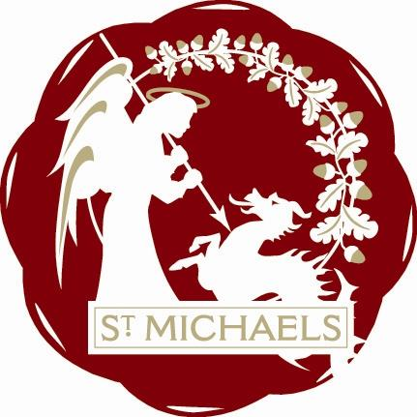
St. Michaels Community Group
Minutes of meeting
Wednesday 15th November 2017
At London Beach at 7.30 p.m.
Present: Mike Dewdney, Rob Solly, Colin Barnes, Jean Curteis, John Hoad, John Link, Lindsay Hammond, Rosemary Dayborn, Sandra Sutters

Apologies: Raymond Crawfurd, Trevor Bingham
Minutes of last meeting and matters arising: Minutes were agreed
Finance: Current balance in the bank is £5104.82. This includes a personal donation from the Mayor of £50 and £200 from The Crown, both in regards to Tributes in the Park.
It was decided to spend up to £75 on a Hamper for the main raffle prize at Christmas, and that all profits from the raffle be doated to local charity Hypo Hounds.
Flowers at the Point: The planters have been planted up for the winter with an underplanting of daffodils for early spring. They are looking good.
Ox Lane Green : The planter has now been filled and planted. The volunteer gardeners have kindly donated all the current plants. They have also varnished the bench at their own cost.
Vandalism at the Rec: The Facebook article has reached over 5000 people. The comments show the concern of local residents and the wish for a police presence. Jean has reported our concerns to Tenterden Town Council and it will be on their agenda at the next appropriate meeting.
Pastoral Visiting: Lindsay will organise this for next year

Christmas: Timing is as follows:-
4.00 Service at the Church
4.30 Candle-light procession to the point
Blessing of the Tree and Remembrance Angels.
5.00 ‘Switch on’ by the Mayor of Tenterden
Carols , and Mulled Wine
5..45 Father Christmas at Village Hall. Fun with the Muppets and Jonathan the magician. Tea, coffee, Mince Pies and Sausage Rolls
And for the Adults -
8.30 At The Crown Pub, Natalie Ward reprises her Tributes in the Park Act.

AOB : If you are shopping in Tesco’s please put the Blue Tesco Tokens in the box for St Michaels Primary School.
St Michaels Village Hall 50 years celebrations on 18th November. Afternoon Tea from 2.30 and a 60’s theme evening from 7,30 Evening cost is £12 which includes supper.

Appointment of Chairman for next Meeting : Rob Solly to take AGM as there is not be a general meeting in December.

Date of Next Meeting: Monday January 15th AGM at 7.00p.m.
General meeting at 7.30

